Influencer Campaign Performance Tracker

1. Problem Statement
Brands invest heavily in influencer marketing campaigns across multiple social media platforms. However, it is difficult to identify which influencers generate the highest engagement, reach, conversions, and return on investment (ROI). This project aims to build an interactive analytics dashboard that helps marketing teams evaluate campaign performance and optimize future investments.

2. Objective
The objective of this project is to analyze influencer campaign data and develop a dashboard that tracks campaign effectiveness, audience behavior, platform performance, and financial outcomes.

3. Dataset Description
The dataset contains influencer marketing campaign information, including:
- Campaign ID
- Influencer Name
- Platform
- Followers Count
- Reach
- Impressions
- Likes
- Comments
- Shares
- Engagements
- Campaign Spend
- Revenue Generated
- Conversions
- Audience Segment
- Campaign Date

4. Data Cleaning and Preparation
The following preprocessing steps were performed:
- Removed duplicate records
- Handled missing values
- Standardized column names
- Converted data types where necessary
- Created calculated metrics such as:
  - Engagement Rate
  - ROI
  - Conversion Rate
  - Cost Per Engagement

Formulas Used
Engagement Rate (%) = (Total Engagements / Reach) × 100
ROI (%) = ((Revenue - Campaign Spend) / Campaign Spend) × 100
Conversion Rate (%) = (Conversions / Reach) × 100
Cost Per Engagement = Campaign Spend / Total Engagements
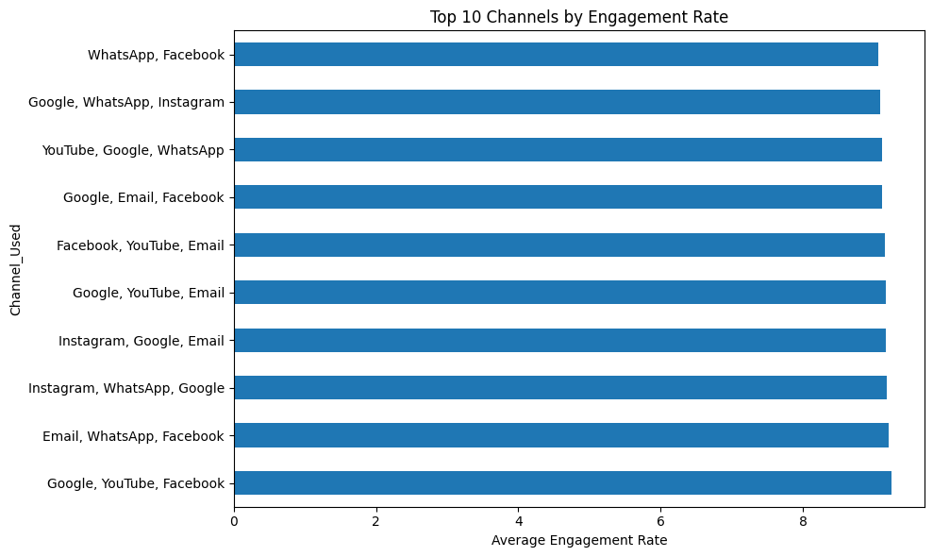

5. Key Performance Indicators (KPIs)

KPI Cards
- Total Campaigns
- Total Reach
- Total Revenue
- Total Spend
- Average Engagement Rate
- Average ROI
- Cost Per Engagement
- Conversion Rate

6. Analytics Investigation

Platform Performance Analysis
- Compared engagement across Instagram, YouTube, TikTok, and Facebook.
- Identified platforms with the highest audience interaction.
- 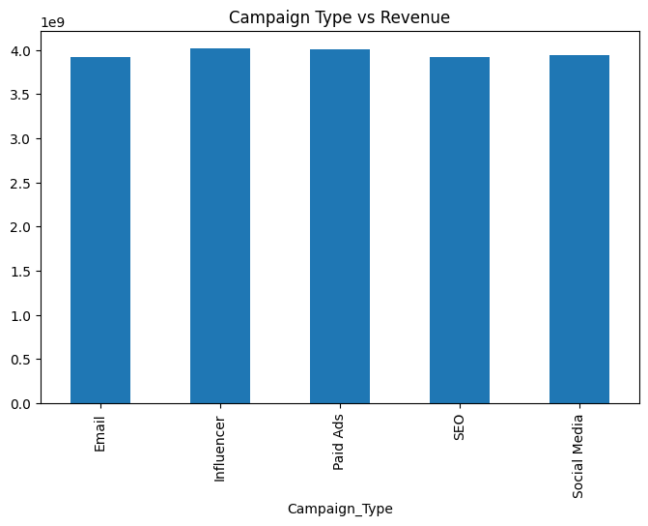

Influencer Performance Analysis
- Evaluated influencer contribution to revenue generation.
- Ranked influencers based on ROI and engagement.
- 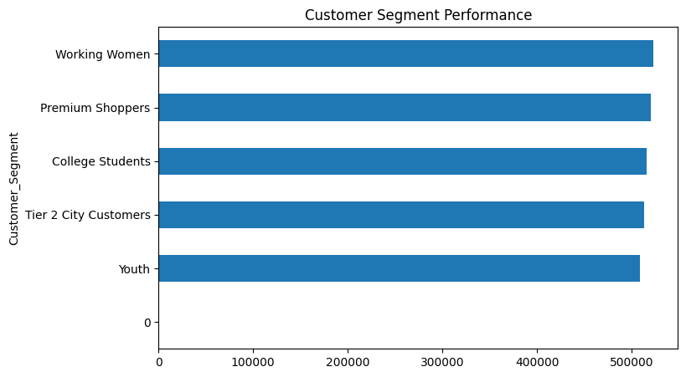

Campaign Cost vs ROI
- Analyzed whether higher spending produced better campaign outcomes.
- Used scatter plots to identify spending efficiency.
- 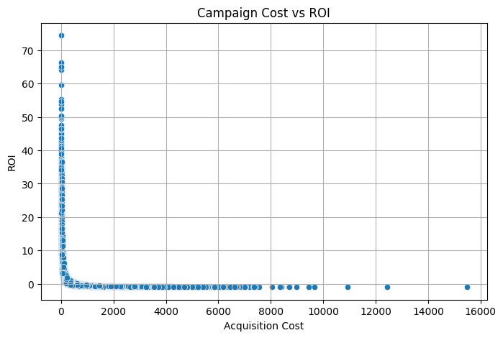

Audience Analysis
- Studied audience segments and conversion patterns.
- Identified audience groups with the highest response rates.
- 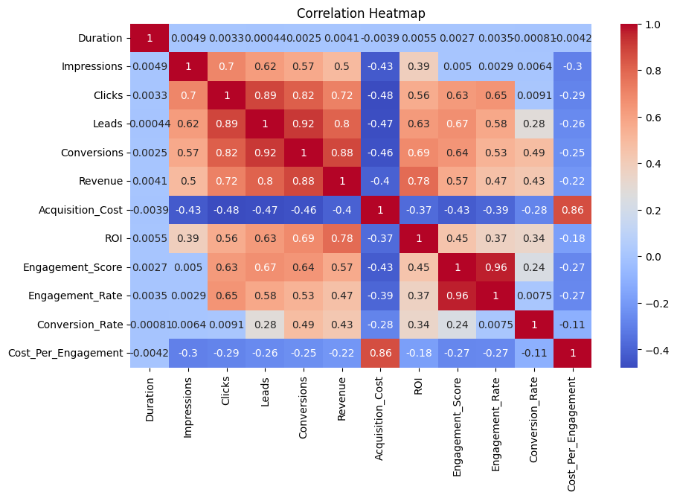

7. Dashboard Development

Executive Overview
Includes:
- Campaign Spending
- Revenue Generated
- ROI Trends
- Campaign Success Metrics
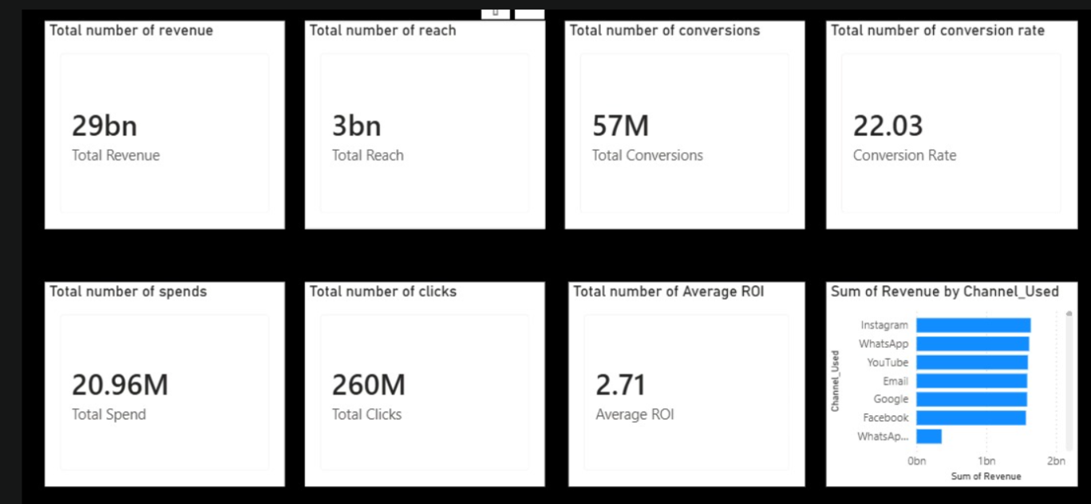

Influencer Analytics Dashboard
Includes:
- Influencer Performance
- Reach Analysis
- Engagement Analysis
- Top Performing Influencers
- 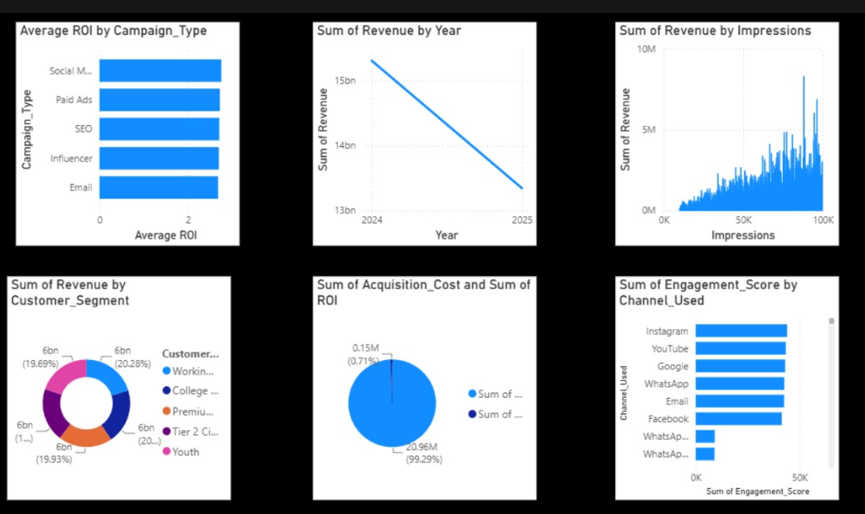

Platform Dashboard
Includes:
- Platform Performance
- Audience Behavior
- Conversion Patterns
- 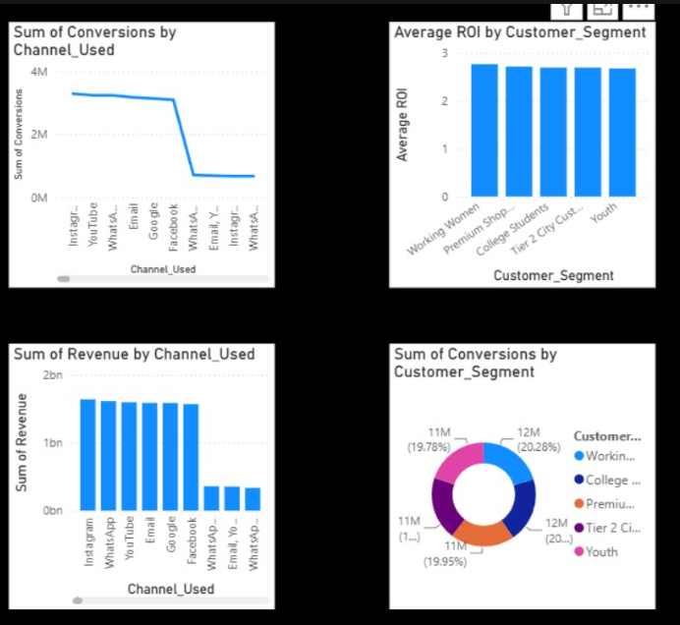

Financial Dashboard
Includes:
- Campaign Cost Analysis
- Revenue Contribution
- ROI Analysis
- Cost Efficiency Metrics

8. Key Findings
- High-engagement influencers generated the strongest campaign performance.
- Instagram and YouTube delivered the highest audience engagement.
- Campaign spending alone did not guarantee higher ROI.
- Certain audience segments showed significantly better conversion rates.
- Micro-influencers often provided better ROI compared to mega-influencers.

9. Recommendations
- Invest more in high-ROI influencers.
- Focus marketing budgets on top-performing platforms.
- Prioritize audience segments with strong conversion rates.
- Optimize campaign spending based on ROI trends.
- Continuously monitor influencer performance using dashboard insights.

Key Business Questions
- Which influencers deliver the strongest campaign performance?
  - Analyze influencer-wise engagement, conversions, revenue, and ROI.
  - Identify top-performing influencers based on campaign outcomes.
- Which platforms generate maximum engagement?
  - Compare engagement metrics across platforms such as Instagram, YouTube, TikTok, and Facebook.
  - Determine the platform with the highest audience interaction.
- Are campaign investments producing positive returns?
  - Calculate Return on Investment (ROI) for each campaign.
  - Compare campaign costs with revenue generated.
- Which audience segments respond best to influencer campaigns?
  - Analyze engagement and conversion rates across different audience demographics.
  - Identify high-performing customer segments.
- How can brands optimize influencer spending?
  - Evaluate cost per engagement and cost per conversion.
  - Recommend budget allocation toward high-ROI influencers and platforms.

10. Conclusion
The Influencer Campaign Performance Tracker successfully provides a comprehensive view of campaign effectiveness. The dashboard enables marketing teams to make data-driven decisions, improve campaign performance, and maximize return on investment.

11. Future Scope
- Predict campaign success using Machine Learning.
- Sentiment analysis of influencer content.
- Real-time campaign monitoring.
- Automated influencer recommendation system.
- Advanced audience segmentation and forecasting.

